Container rates near $9,000 as Iran war flares

Stuart Chirls, Wednesday, July 08, 2026
Original Article: https://www.freightwaves.com/news/container-rates-near-9000-as-iran-war-flares
Articles Reproduced by Permission of FreightWaves

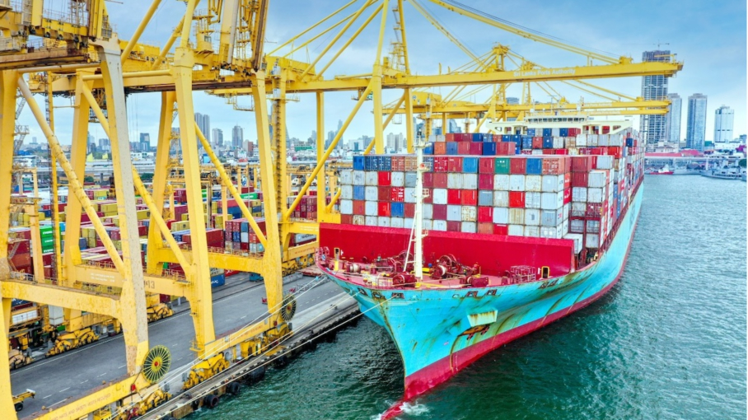
Port of Colombo, Sri Lanka. (Photo: Sri Lanka Ports Authority)

Amid uncertain peak, demand helps carrier surcharges stick

Just when it looked safe to go back in the water, the United States and Iran restart hostilities, and container rates on the busiest U.S. trade lane near a three-year high.

Prices on the benchmark Asia-U.S. trans-Pacific levelled off 8% higher than the previous week, according to SONAR data analyst Freightos, as rates have yet to reflect declining fuel costs.

“Peak season demand continues to push rates higher – though the early start to this year’s busy season may mean volumes are already near their peak,” Freightos (NASDAQ: CRGO) research chief Judah Levine wrote in a weekly note to clients.
General rate increases and peak season surcharges by carriers that took effect July 1 added about $1,000 per forty foot equivalent unit across major east-west lanes, said Levine. That’s brought total trans-Pacific increases to more than $3,000 per FEU since late May.

“West Coast rates are around $6,700 per FEU and East Coast rates are leveling off near $9,000 per FEU,” Levine said.

Mideast tensions flared Tuesday amid Iranian strikes and U.S. retaliation in the most serious escalation since the ceasefire began. President Donald Trump, meeting in Turkey with NATO leaders, said that the fragile ceasefire was ‘over’.

The rejoined war is particularly ill-timed for Maersk (OTC: AMKBY). The Danish liner this week announced what is supposed to be a gradual return to the Suez Canal-Red Sea route as part of its Gemini service with Hapag-Lloyd. Maersk earlier this year saw a similar return halted nearly before it began as violence spread through the Mideast. Houthi rebels in Yemen have again warned of violence directed at Israel-linked shipping.

Levine said that while crude oil prices have fallen back to pre-war levels, supply is recovering faster than expected and raising concerns of oversupply.

“Bunker and jet fuel prices are easing but remain 20%-30% above pre-war levels, as refined products take longer to normalize than crude,” he said.

Despite liners deploying record capacity, Europe rates have also surged. with Asa-North Europe at about $5,400 per FEU and Mediterranean prices passing $7,000 per FEU.

“Carriers have another about $2,000/FEU in mid-July increases planned,” said Levine, “but like on the trans-Pacific, early demand peaking could limit how much sticks.”

He said any rate relief could be slowed by backlogs of rolled cargo – delayed or shifted from schedule – and significant congestion at major Asia hubs including Shanghai, Ningbo and Yantian in China, Singapore, South Korea’s Busan and Colombo in Sri Lanka.

